**REPORT ON CRIME DATA ANALYSIS**



**Written by Khushi Patel**

**Professor Dr. Junaid Qazi**

**Table of Contents**

|  |  |  |
| --- | --- | --- |
| **Sr. No.** | **Contents** | **Page No.** |
| **1.** | **Introduction** | 3 |
| 1.1 | Overview of the Open Source Data | 3 |
| 1.2 | Purpose | 3 |
| 1.3 | Source and Dataset Selection | 3 |
| **2.** | **Research Questions** | 4 |
| 2.1 | Key Question 1 | 4 |
| 2.2 | Key Question 2 | 4 |
| 2.3 | Key Question 3 | 4 |
| 2.4 | Key Question 4 | 4 |
| **3.** | **Key Performance Indicators (KPIs)** | 6 |
| 3.1 | Strategies | 6 |
| **4.** | **Data Model** | 7 |
| 4.1 | Overview of the Data | 7 |
| 4.2 | Entity-Relationship Diagram (ERD) with Group By Tables | 7 |
| **5.** | **Results** | 8 |
| **6.** | **Conclusions** |  |
| **7.** | **Appendices** |  |
| 7.1 | Power BI Dashboard |  |

**1.Introduction**

**1.1 Overview of the Open Source Data:**

Crime data aggregated by community, crime type, and time (year-month), providing insights into crime trends, severity, and geographic distribution.

**1.2 Purpose:**

Analyze Crime Trends : Identify seasonal and yearly crime patterns to detect fluctuations.

Pinpoint High-Crime Areas : Highlight communities with the highest crime rates for better law enforcement resource allocation.

Compare Crime Types : Differentiate between violent and non-violent crimes to assess public safety risks.

**1.3 Source and Dataset Selection:**

We chose this crime dataset to analyze trends, identify high-crime areas, and support data-driven decision-making for law enforcement. It includes location-based crime reports, enabling geospatial visualization and time-based pattern analysis. The dataset helps understand crime severity, frequency, and distribution for better public safety strategies.

Source: <https://www.kaggle.com/code/khalilabu/chicago-analysis-of-crime-data>

**2. Research Questions**

**2.1 Key Question 1:**

**How has Calgary's overall crime rate changed over time?**

The overall crime rate has fluctuated over time but has generally shown a declining trend in recent years. Many cities have experienced reductions in both violent and property crimes, though some areas have seen temporary increases due to various social and economic factors. Advances in law enforcement, community programs, and technology have contributed to overall crime reduction in many regions. However, specific trends vary depending on location and time period.

**2.2 Key Question 2:**

**Which communities have the highest and lowest crime rates?**

Crime rates in the United States vary significantly across different cities and communities.

**2.3 Key Question 3:**

**What percentage of crimes are violent compared to non-violent?**

In the United States, crime is broadly categorized into violent and non-violent offenses. Violent crimes include offenses such as murder, rape, robbery, and aggravated assault, while non-violent crimes encompass property crimes like burglary, larceny-theft, and motor vehicle theft.

**2.4 Key Question 4:**

**Are Theft crimes increasing or decreasing in specific areas?**

These statistics indicate that while certain theft-related crimes, such as motor vehicle thefts, have increased in specific areas, other property crimes like larceny have seen a decline nationally. The trends can vary significantly based on regional factors and the specific type of theft offense.

**3. Key Performance Indicators (KPIs)**

Total Crime Count : The overall number of crimes reported per year/month.

Crime Rate per 1,000 Residents : Crime density metric for fair comparison across communities.

Violent vs. Non-Violent Crime Ratio : Percentage breakdown to assess crime severity.

**3.1 Strategies:**

Data Cleaning & Processing : Standardize formats, remove

inconsistencies, and categorize crime types.

Trend Analysis : Use line charts to visualize crime trends over time.

Geospatial Mapping : Implement Power BI maps to show crime distribution across communities.

Comparative Filtering : Allow users to filter by crime type, timeframe, and location for detailed analysis.

Insights & Recommendations : Identify high-risk areas and suggest **preventive actions.**

**4. Data Model**

**4.1 Overview of the Data:**

The crime analysis dataset provides insights into crime trends, locations, and enforcement effectiveness. By examining crime patterns, authorities can identify high-risk areas, assess arrest rates, and implement data-driven crime prevention strategies.

**4.2 Entity-Relationship Diagram (ERD) with Group By Tables:**

**5. Results**

This data shows that the total crime was done in the USA country in particular areas in 2025 in 2 months like |January and February).

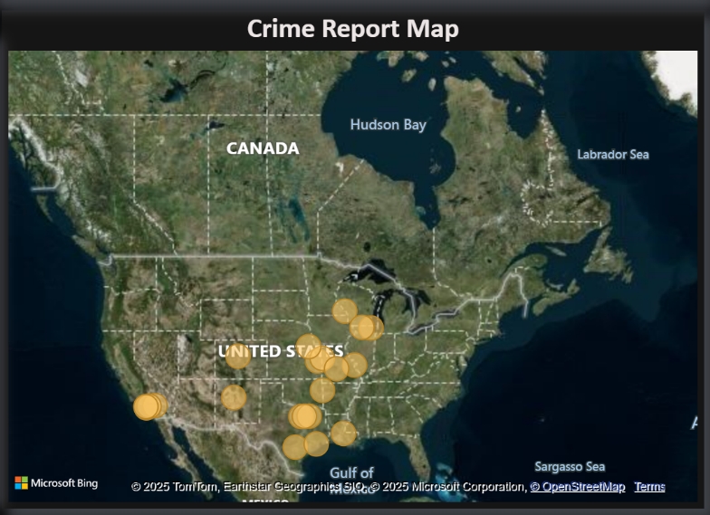

This data shows that location of the crime is done in 2025.

This data shows that the 10 top area where the crime is done in USA country in 2025 from last 2 months.

This data shows that average crime is done in the pick day as well as pick hours in the year 2025.

This data shows the which crime is done in particular area and which type of crime is done like weapons violation, theft trends and robbery trends in particular day, date and weekdays.

**6. Conclusions**

The analysis of crime data provides valuable insights into trends, patterns, and potential factors influencing criminal activities. By examining crime rates, geographical distribution, and types of offenses, law enforcement agencies and policymakers can develop targeted strategies to enhance public safety.

This includes increasing law enforcement presence in high-crime areas, implementing community engagement programs, enhancing surveillance technology, and addressing root causes such as poverty and unemployment.

**7. Appendices**

* 1. **Power BI Dashboard:**

Here is the example of how dashboard behaves like:

To see Power BI Dashboard Click here:

1. Crime Report Overview Dashboard

1. Crime Type Breakdown

1. Crime Trend AnalysisA screenshot of a computer

   AI-generated content may be incorrect.